**TASK: 01**

**Create directories which would have the following structure by using only mkdir command:**

**HIERARCHY:**

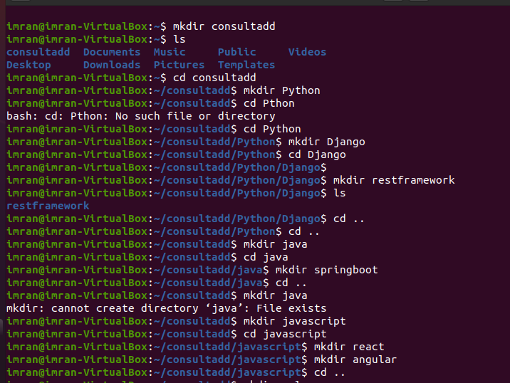

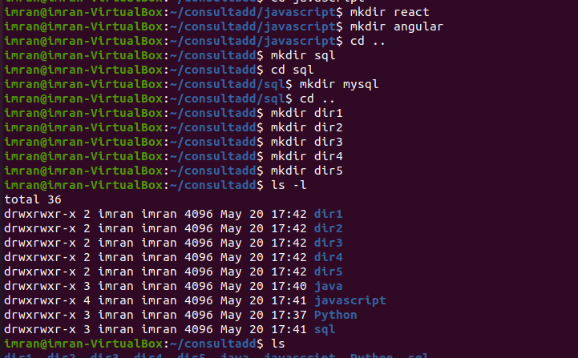

* Create Directory called consultadd
* Inside that create 5 more directories named them as dir1, dir2, dir3, dir4 and dir5

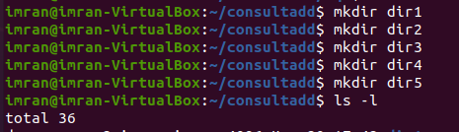

* What would be the output of Long Listing after creating these directories?

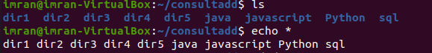

* List all the directories with ls and echo * and see the difference.



* Create a 2 files named them file1.txt and file2.txt inside dir3



* Move dir5 into the dir3





* Remove dir 3 after moving all files from dir3 to dir2.
* Go to the dir2 and create one more file with name index.html
* Move to top level directory



* Check the permission of all files and directory from current place make sure when you do **pwd** it should be on consultadd



* Rename all files of dir2 with extension of .txt to .py

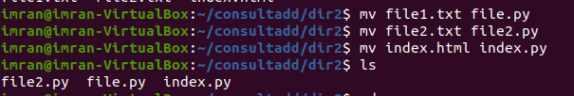

**TASK: 03**

* What is Nano Editor?

GNU nano is an easy to use command line text editor for Unix and Linux operating systems. It includes all the basic functionality you’d expect from a regular text editor, like syntax highlighting, multiple buffers, search and replace with regular expression support, spellchecking, UTF-8 encoding, and more.

* + How to create a sample file in Nano Editor?

nano (filename)

* + How to save file?

Ctrl + o

* What is Vi Editor?

The default **editor** that comes with the UNIX operating system is called **vi** (visual **editor**). Using **vi editor**, we can edit an existing file or create a new file from scratch. we can also use this **editor** to just read a text file.

* + Operation in Vi Editor

The UNIX vi editor is a full screen editor and has two modes of operation:

Command mode commands which cause action to be taken on the file, and

Insert mode in which entered text is inserted into the file.

**TASK: 04**

* Type **finger** to see your account and name.



* Type **cal** to see this month’s calendar.

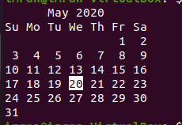

* Create a file and give a name random.txt to it with content into it which say “Hello Welcome to the Consultadd Inc Bootcamp”.



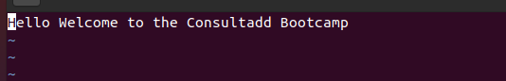

* Display the same content using **cat** command.



**TASK: 05**

* Explain the workflow of the Internet in one paragraph.

Every computer or network device connected to the internet has two things true about it, a physical connection is established via a physical cable or a wireless device and it has software necessary to interpret/send/receive the various internet protocols. The protocol refers to the way in which data is transferred from one device to the next. For instance, web page viewing uses a different protocol than sending email. Fortunately, software does all of this automatically for us, so we don't need to understand the underlying technology. But, we do need to understand the high level basics of what is going on. For example, The end user opens a web browser and types in a URL, which is the name of the website they are wanting to see. The URL request is sent through their LAN to their internet service provider, then the internet service provider then sends the URL requested to an external DNS server, which is either hosted by them or by whoever provides their internet access. The external DNS server then matches the URL up with the external IP Address assigned to the LAN hosting that website and the request is then sent on to that network. The network hosting that website accepts the request and then sends it to its own internal DNS server. The internal DNS server matches the URL requested to the internal IP address of the actual web server where the files making up the website are physically stored. The request is then sent to the web server and the web server packages up the files that make up the website requested. The website that is all packaged up now makes the return trip in reverse all the way back to the computer that originally made the request. The web browser on that computer then interprets the text files full of computer code sent to it by the web server hosting the site and displays them as a graphic website.

* How LAN is different from the WAN network?

A LAN (local area network) is a group of computers and network devices connected together, usually within the same building. By definition, the connections must be high speed and relatively inexpensive (e.g., token ring or Ethernet). Most Indiana University Bloomington departments are on LANs.